**Data visualization with Data Refinery**

**Use IBM Cloud Pak for Data to filter, clean, and visualize data**

## **Learning objectives**

**In this tutorial, you will learn how to**

1. Load data into the IBM Cloud Pak for Data platform for use with Data Refinery.
2. Transform a sample data set, either by entering command-line R code or selecting menu operations
3. Profile the data
4. Visualize data with charts and graphs

## **Prerequisites**

* [IBM Cloud Pak for Data](https://www.ibm.com/analytics/cloud-pak-for-data)

**1:Fllow below mention steps to use IBM cloude Pak**

* When you click on the link [IBM Cloud Pak for Data](https://www.ibm.com/analytics/cloud-pak-for-data) you will get below screen

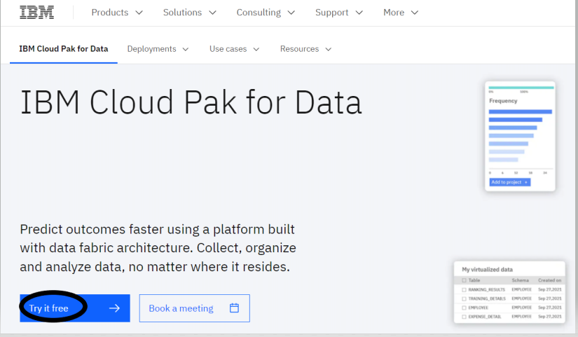

* When you click on try it free following screen will open up
* On this screen click on the check box on the right bottom corner and then click on login with your IBM Account

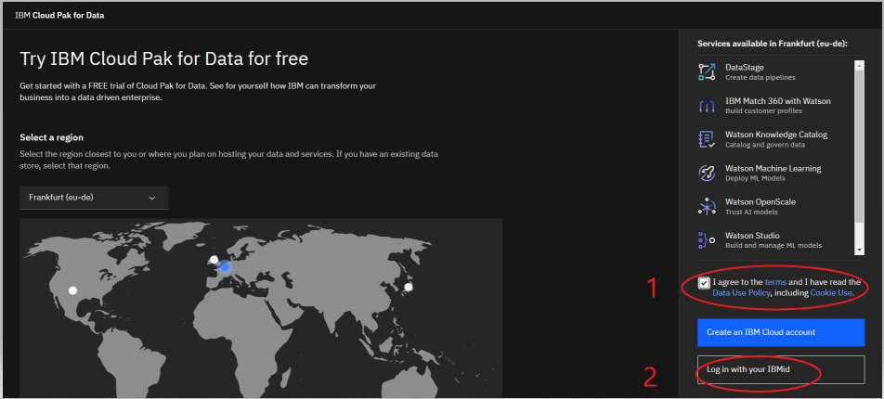

* Onces, you click on “Login with IBMid ” you will get below screen on which you have to enter the IBM Id and after clicking on the two checkboxes click on the continue button

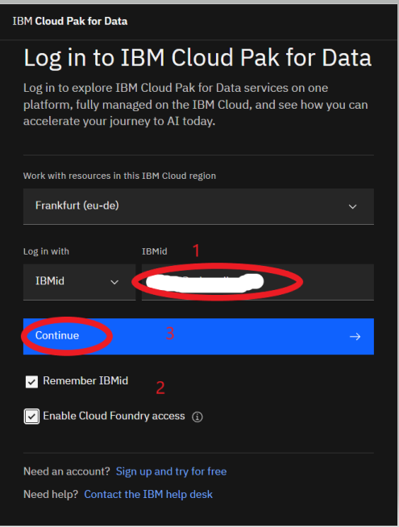

* Ones you click on the continue button you will be asked to enter your IBM account password and click on the login button

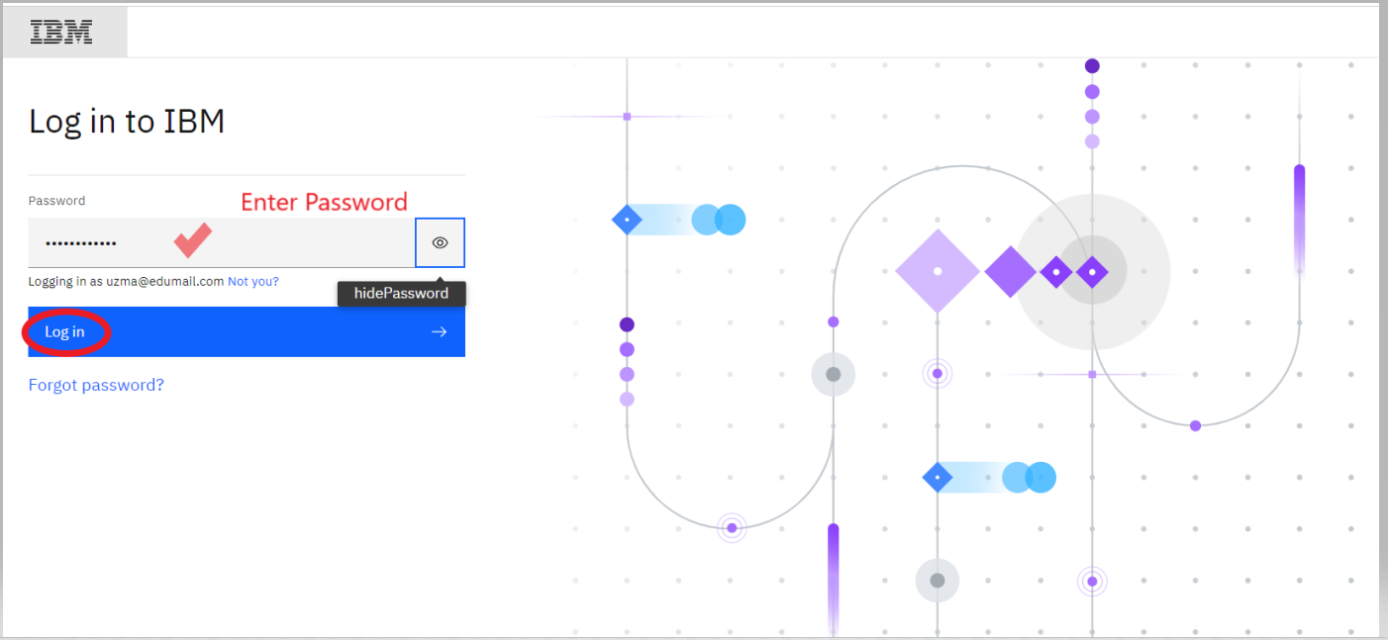

* After you clicked on login button you will get a verification code in your mail id copy that code and past it in the textbox and then click on verify button

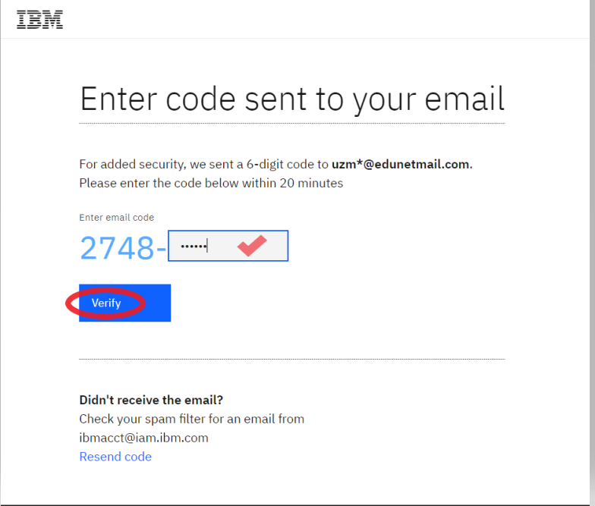

* Onces, you click on verify button you will get a screen to enter your company name and phone number

***Note: Enter the company name you entered while creating the account on IBM Cloude and click on continue button***

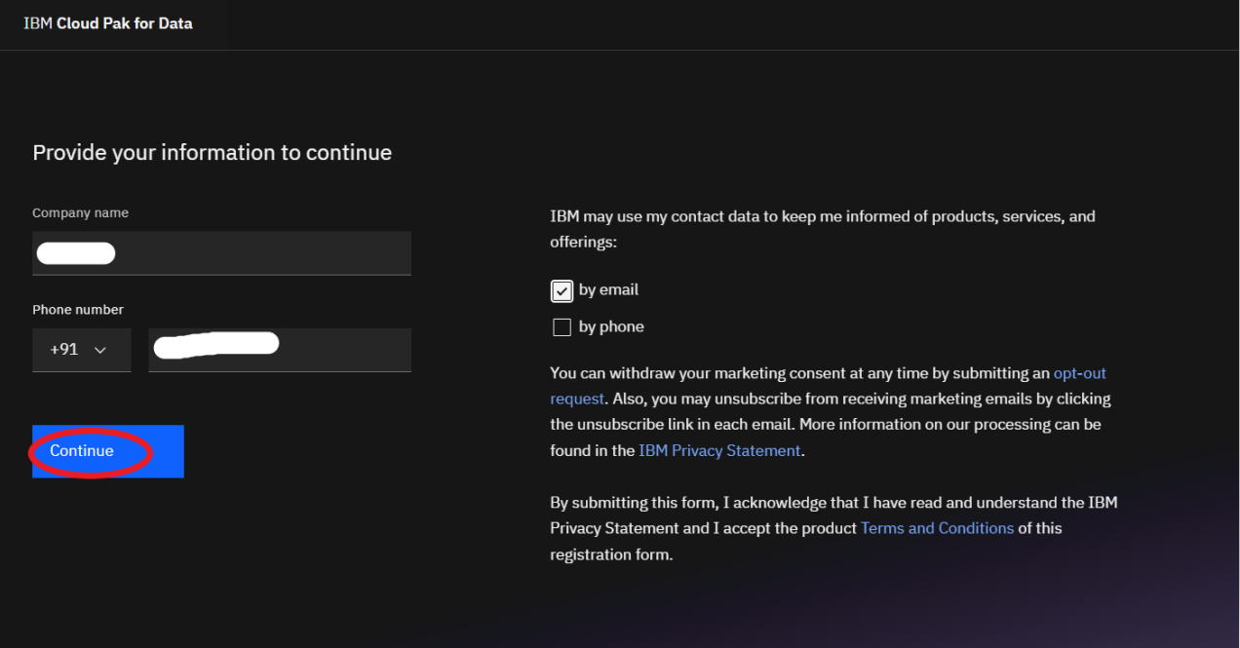

* After clicking on the Continue button you will get below screen

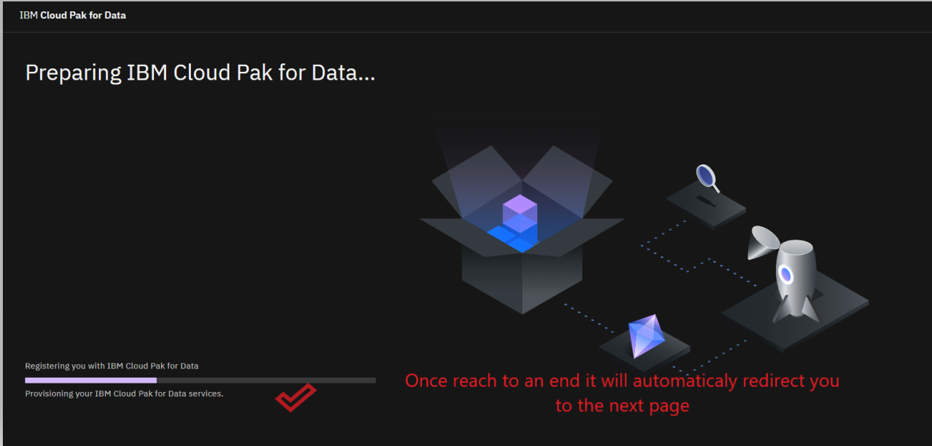

* On the above screen there is a progress bar which when comes to end it will take you to the welcome page as below

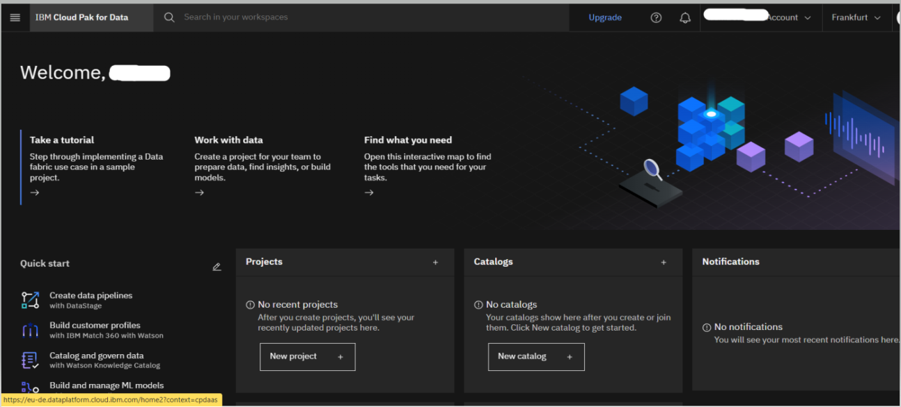

**2:Let's now load the dataset first**

### Load the german_credit_data.csv data into Data Refinery

* Download the [german_credit_data.csv](https://s3.us.cloud-object-storage.appdomain.cloud/developer/default/tutorials/data-visualization-with-data-refinery/static/german_credit_data.csv) file to your local machine.
* After downloading the dataset click on the New Project

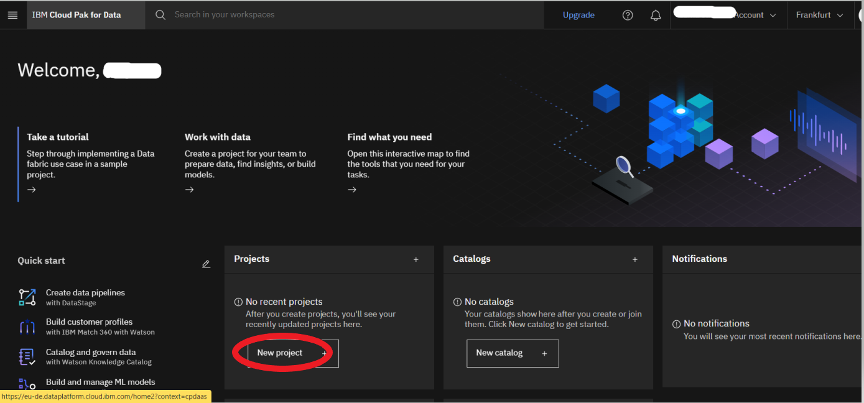

* Following page will open up from given two options select the first option of Create an Empty Project

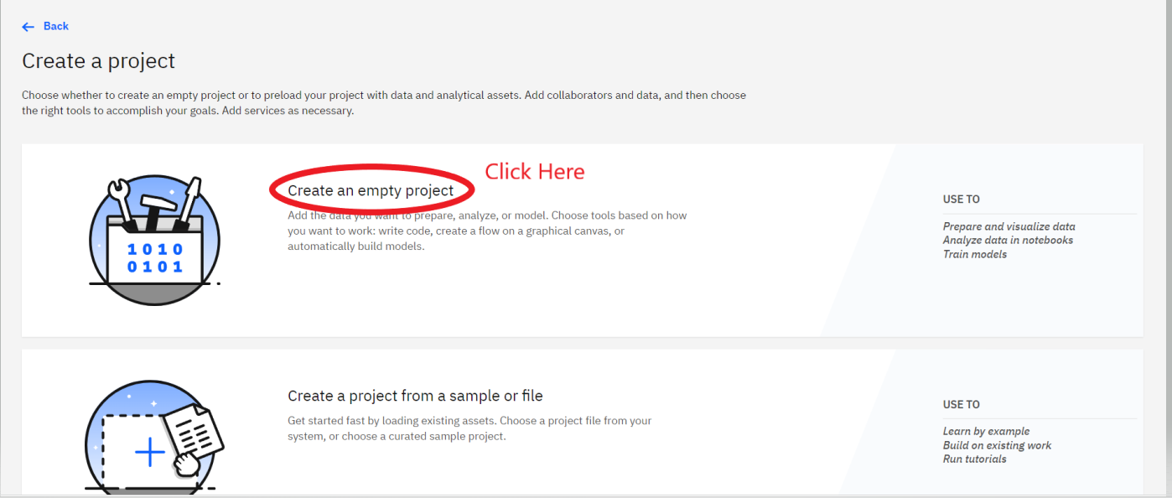

* Below screen will ask you for entering the project name make sure not to enter spaces or underscores
* Onces, you entered a name click on the create button

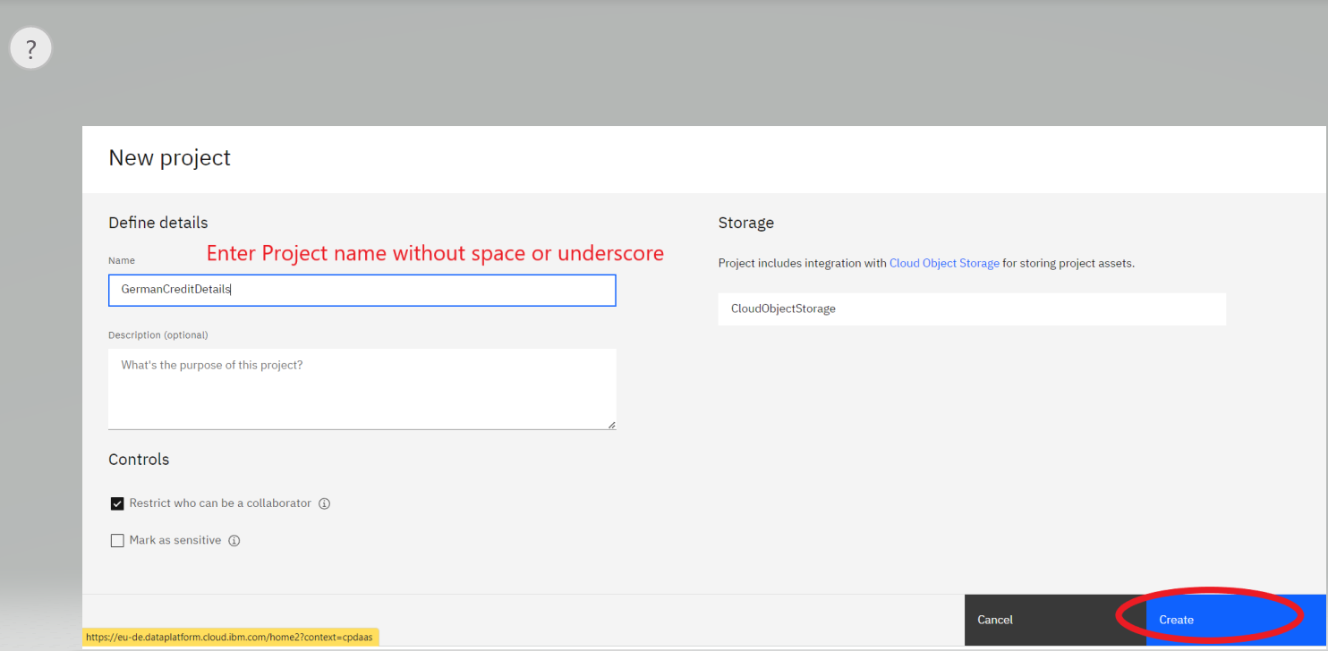

* A new Project will be created with the given name now to load a dataset click on the Asset Tab

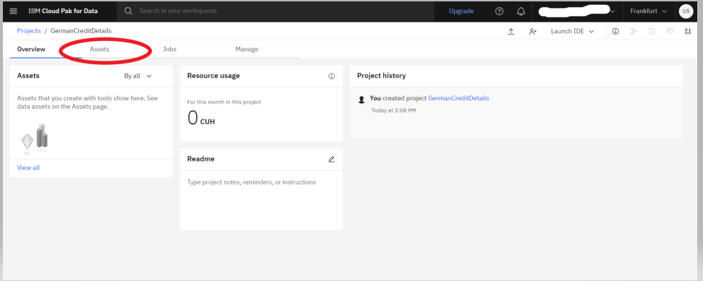

* This tab will allow you to upload the data from your computer
* Click on browse for file link on the left hand side

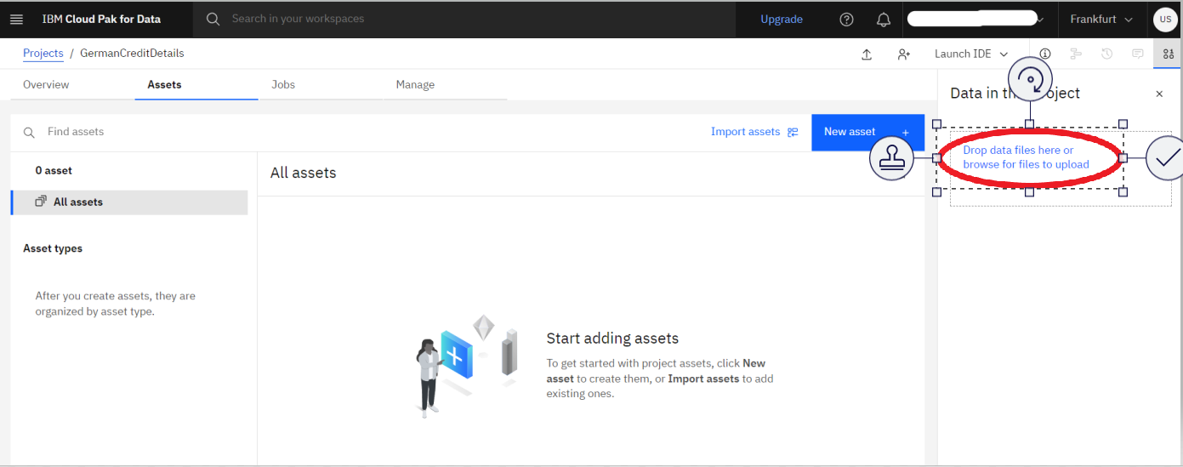

* A dialog box asking your filename to upload will open select the file and click on open

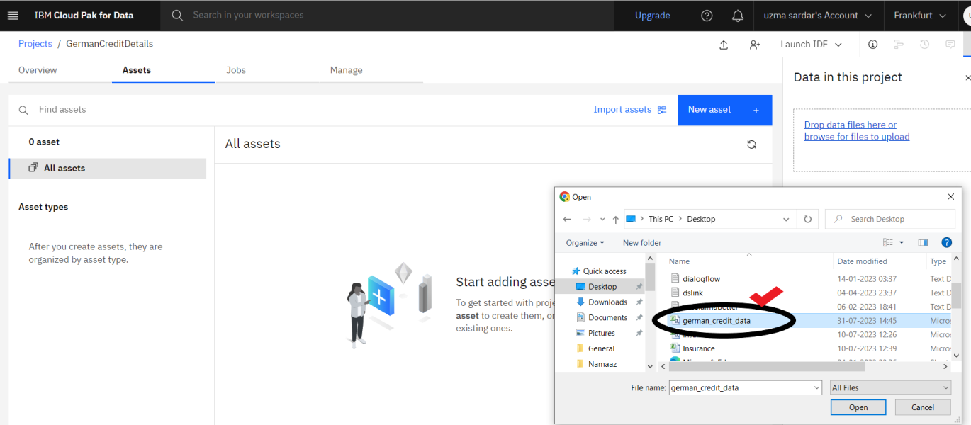

* Once the file is uploaded you can be able to view It in the window like this

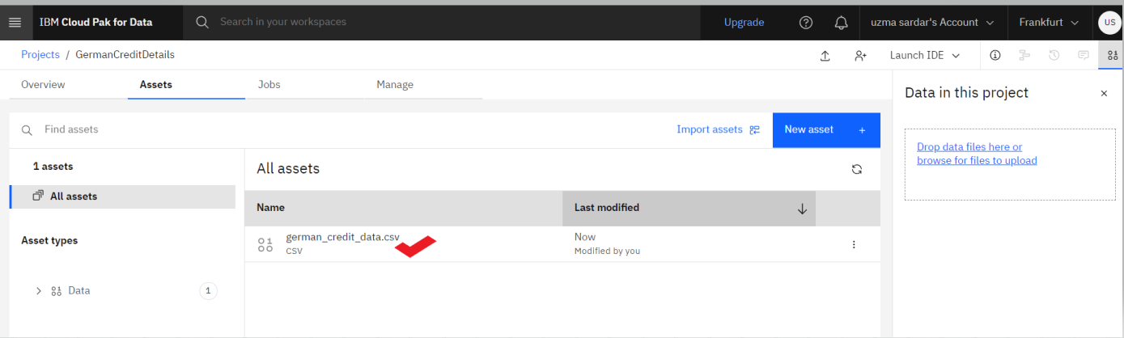

Now let's start learning how to prepare our data for virtualization

* You should be able to see the data as shown below. Click on Prepare Data.

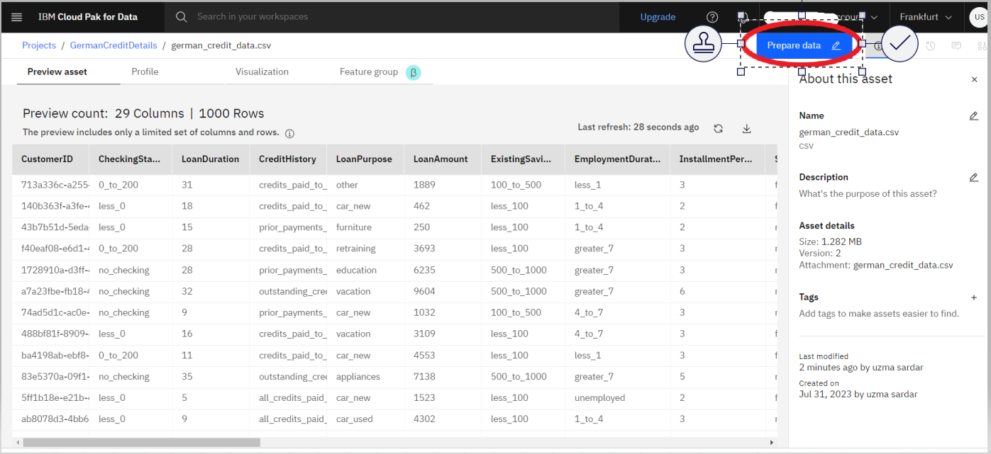

* Data Refinery will launch and open to the Data tab. It will also display the information panel with details of the data refinery flow and where the output of the flow will be placed. Go ahead and click the X to the right of the Information panel to close it.

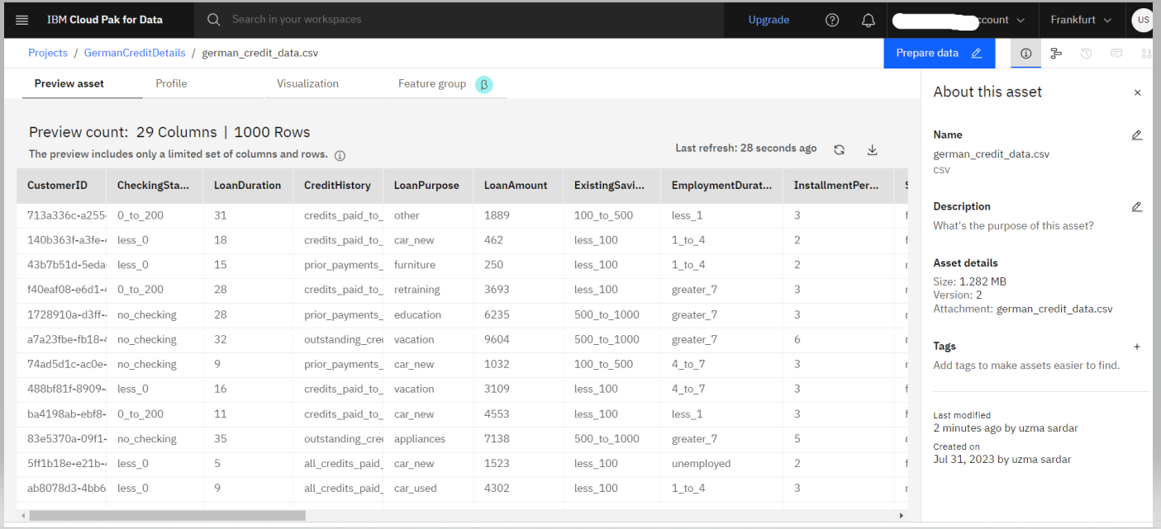

## 2. Refine Data

We'll start out in the Data tab where we wrangle, shape and refine our data. As you refine your data, IBM Data Refinery keeps track of the steps in your data flow. You can modify them and even select a step to return to a particular moment in your data’s transformation.

### Create Transformation Flow

* With Data Refinery, we can transform our data by directly entering operations in [R syntax](https://cran.r-project.org/manuals.html) or interactively by selecting operations from the menu. For example, start typing filter on the Command line and observe that the list of operations displayed will get updated. Click on the filter operation.

* A filter operation syntax will be displayed in the Command line. Clicking on the operation name within the Command line will give hints on the syntax and how to use the command. For instance, to filter for customers who have paid credits up to date, build the expression shown below. To inact the filter, you would Apply the expression.

filter(`CreditHistory` == 'credits_paid_to_date')

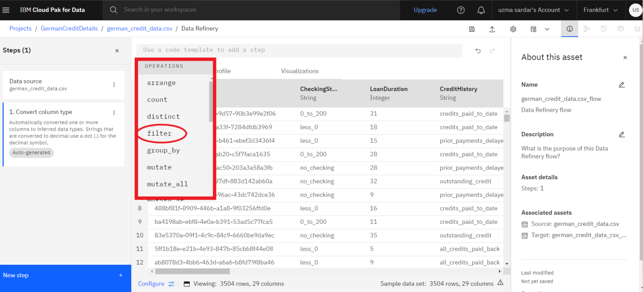

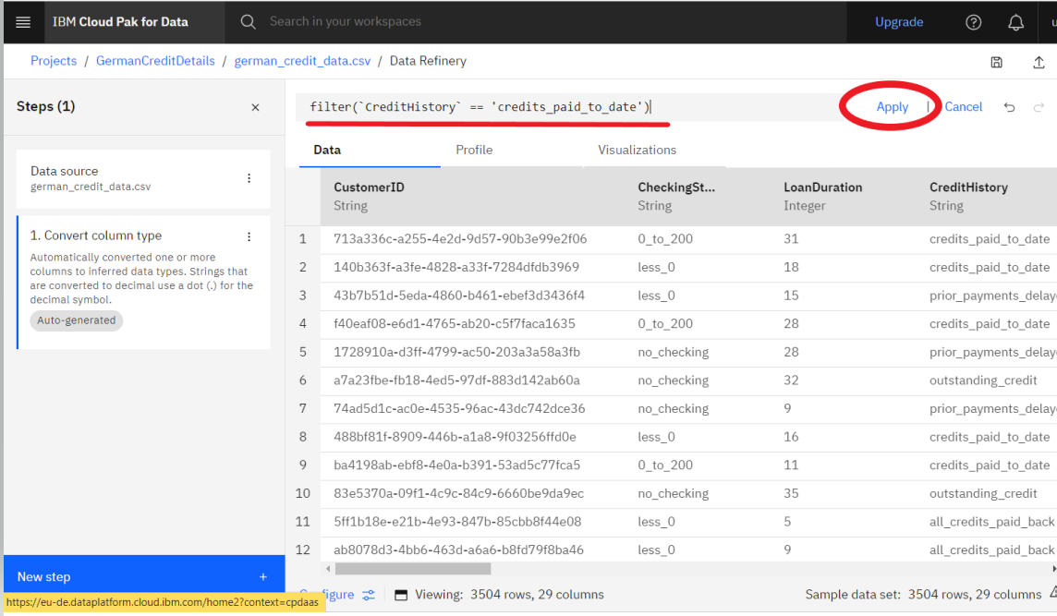

* When you click on the apply button you will see all the records arrange according to filter condition

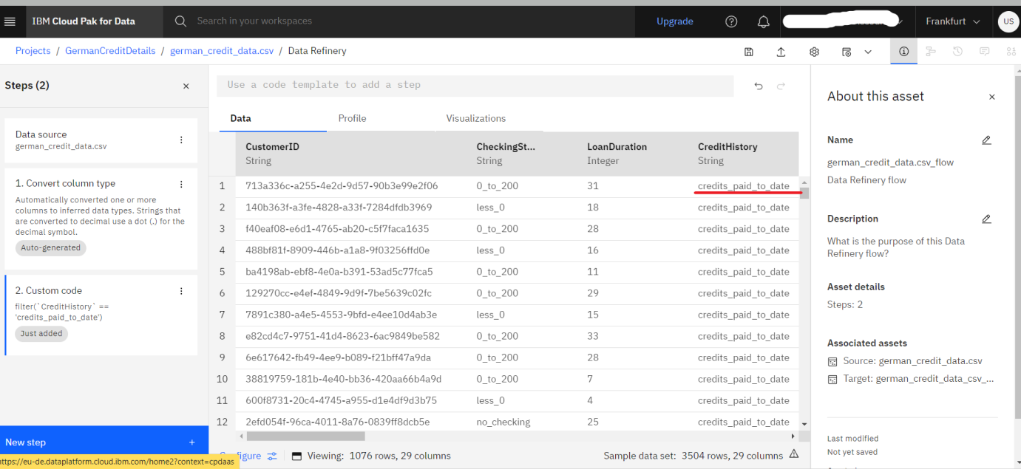

Show more

* We can remove this custom filter by clicking on the trash icon on the Custom code step of our data workflow.

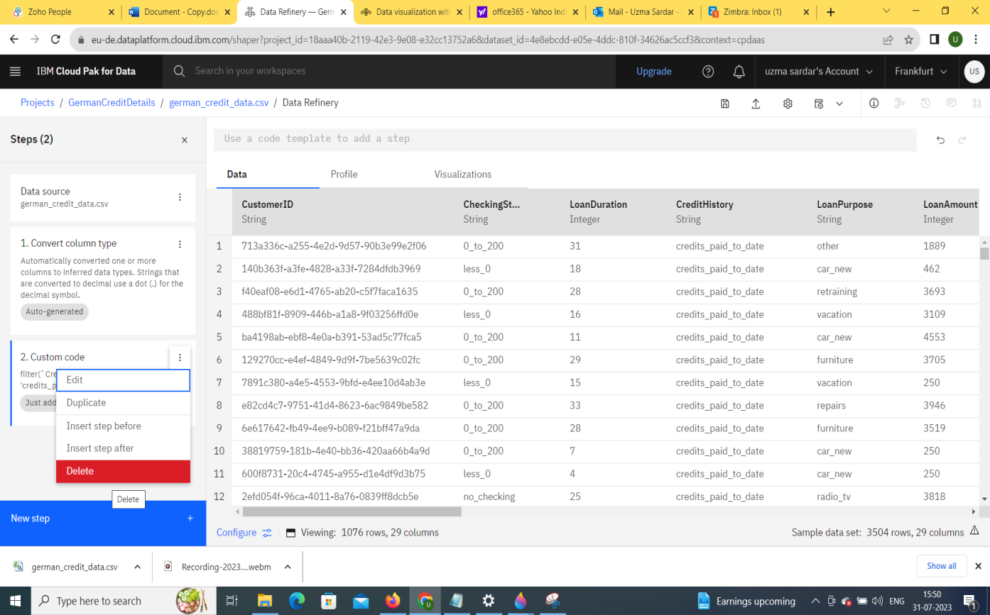

* We will use the UI to explore and transform the data. Click the +NewStep button.

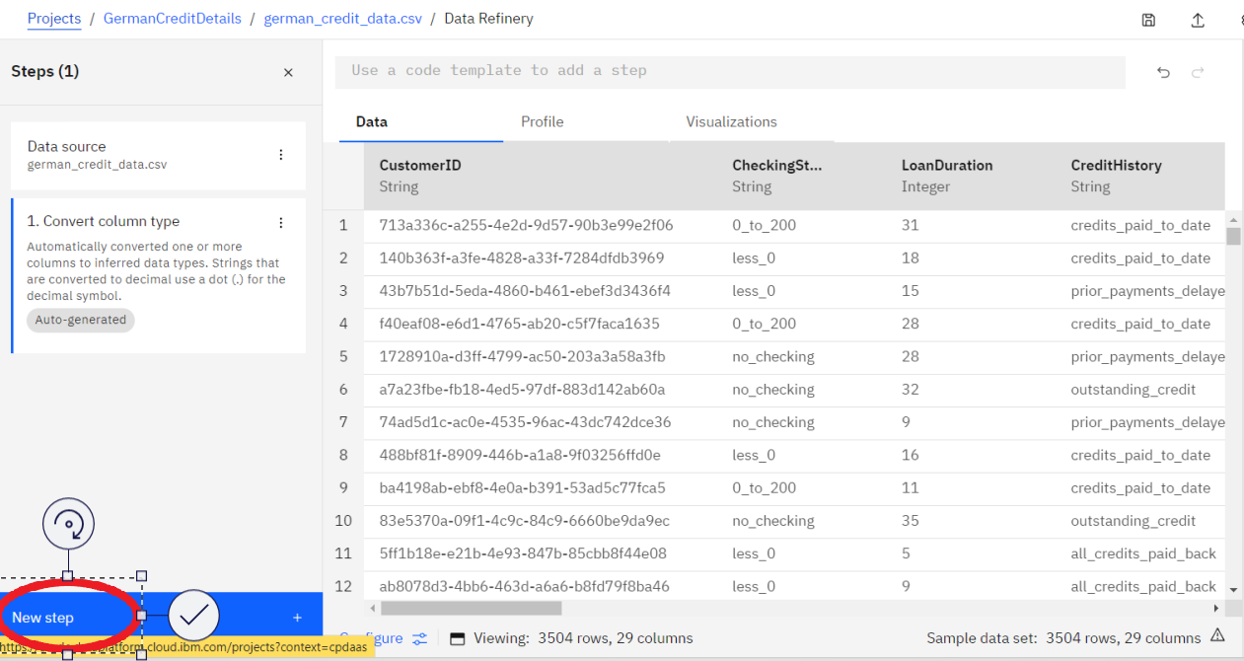

* Let's use the Filter operation to check some values. Click on Filter in the left panel.

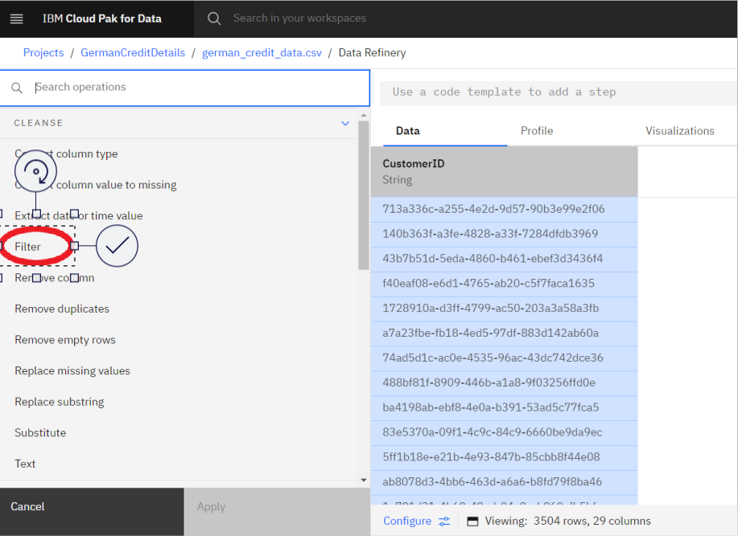

* We want to make sure that there are no empty values in the StreetAddress column. Select the StreetAddress column from the Column drop down list, select *Is empty* from the Operator drop down list, and then click the Apply button.

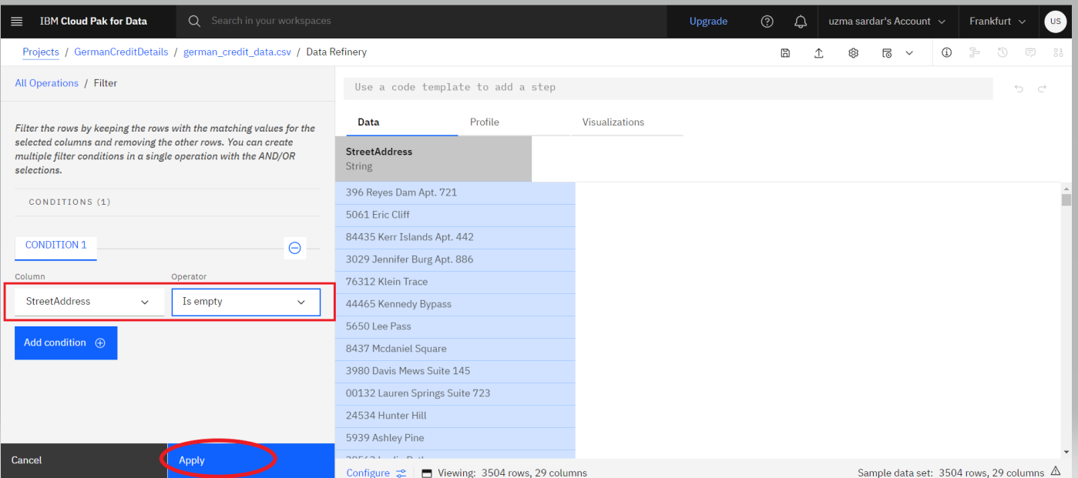

*Note: If there are records where the selected column is empty, they will be displayed after clicking the apply button. If there are no records for this filter, it means that the rows being sampled do not have any empty values for the selected column.*

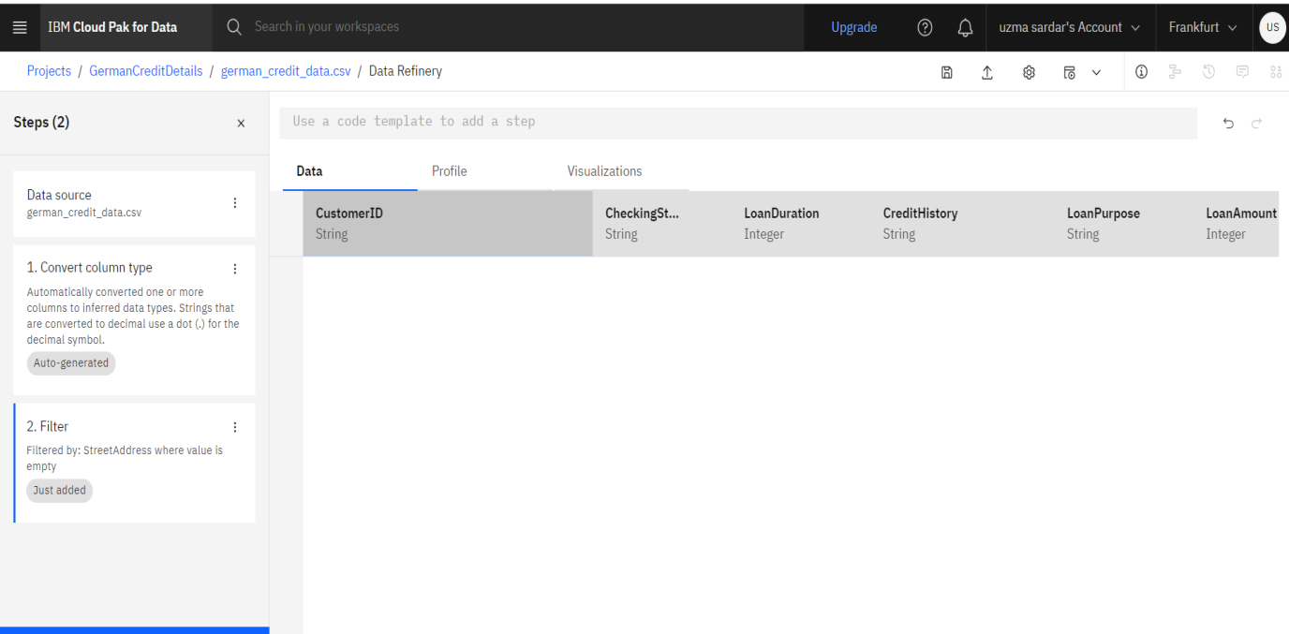

* Now, click on the counter-clockwise "back" arrow to remove the filter. Alternately, we can also remove the filter by clicking the trash icon for the Filter step in the Steps panel on the right.

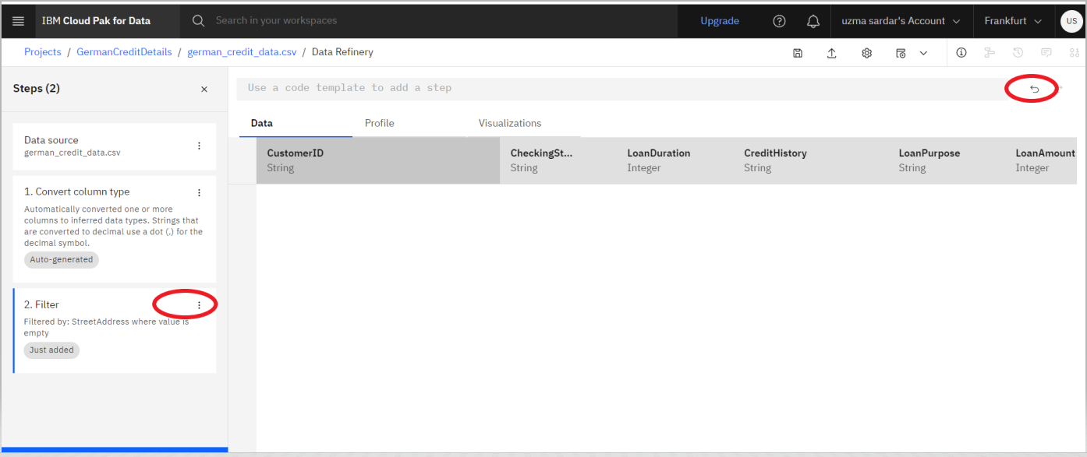

We can remove these records with empty values. Click the +NewStep again and this time select the Remove empty rows operation. Select the StreetAddress column, then click the Next button and finally the Apply button.

Let's say we've decide that there are columns that we don't want to leave in our dataset ( maybe because they might not be useful features in our Machine Learning model, or because we don't want to make those data attributes accessible to others, or any other reason). We'll remove the FirstName, LastName, Email, StreetAddress, City, State, PostalCode columns.

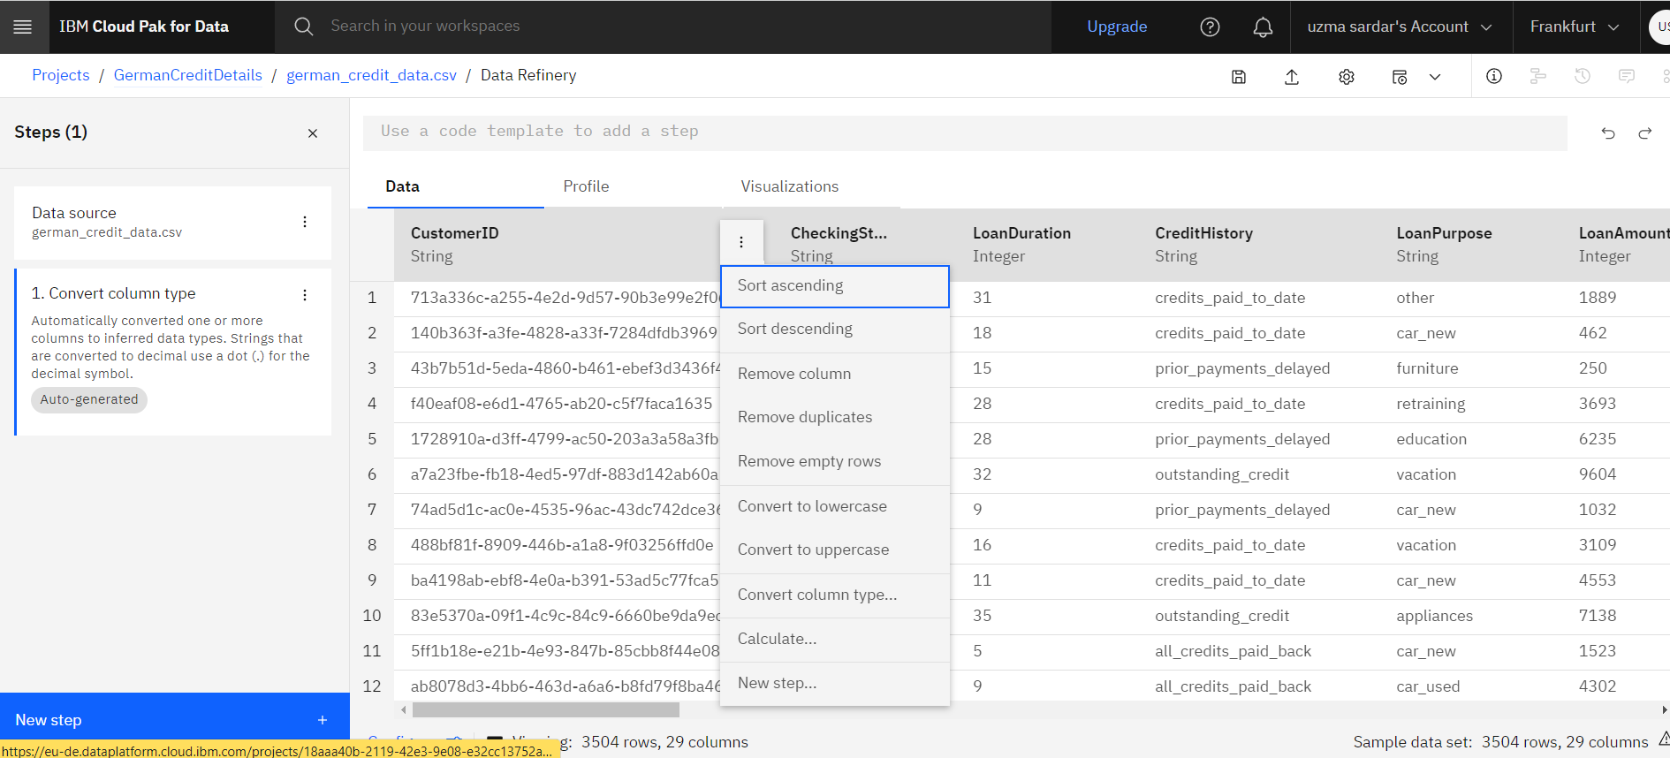

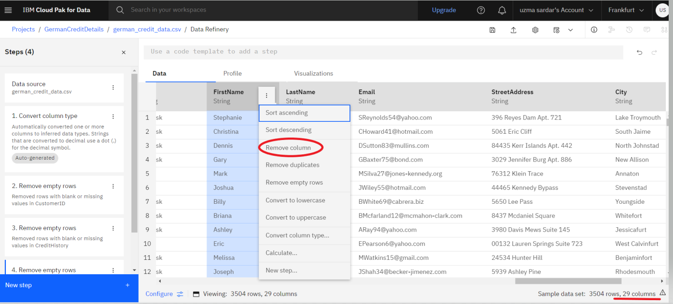

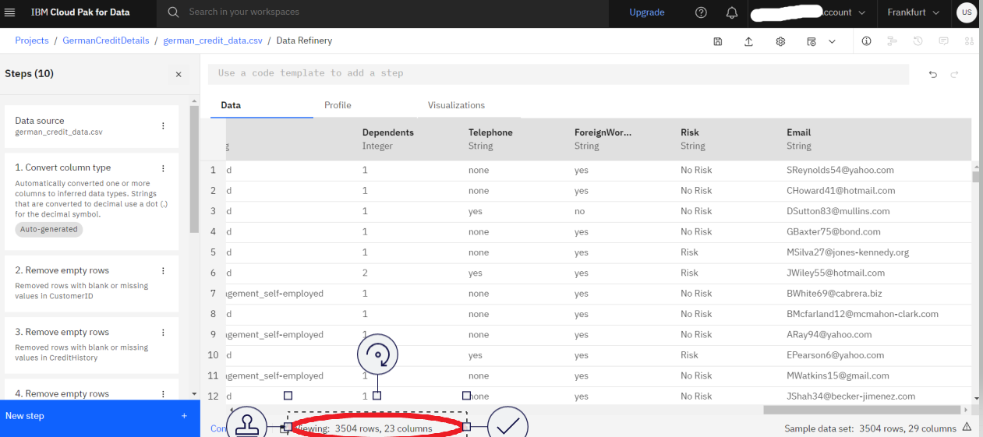

At this point, you have a data transformation flow with 8 steps. As we saw in the last section, we keep track of each of the steps and we can even undo (or redo) an action using the circular arrows. To see the steps in the data flow that you have performed, click the Steps button. The operations that you have performed on the data will be shown.

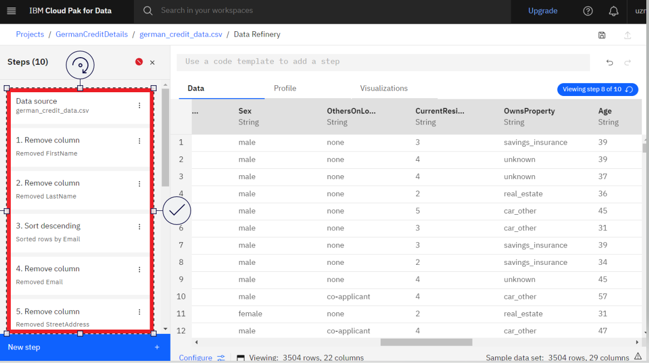

* By clicking on the below button you can save the data. You can modify these steps in real time and save for future use.

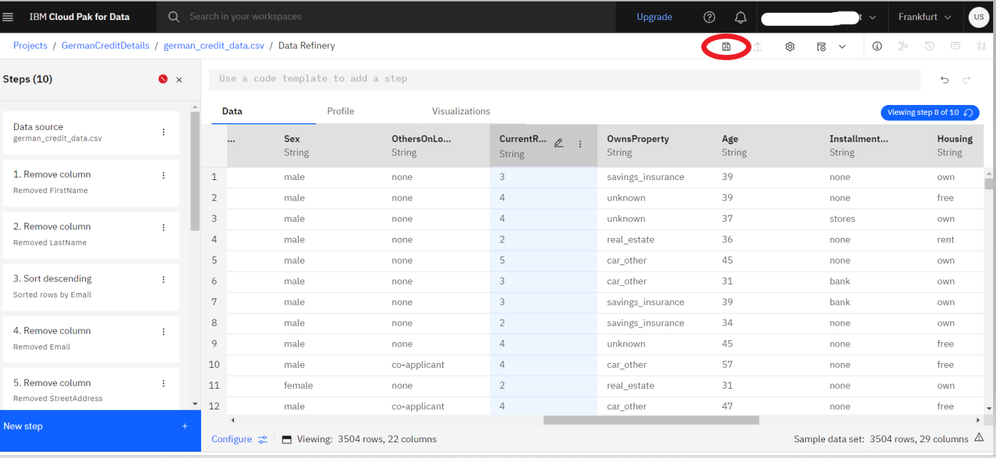

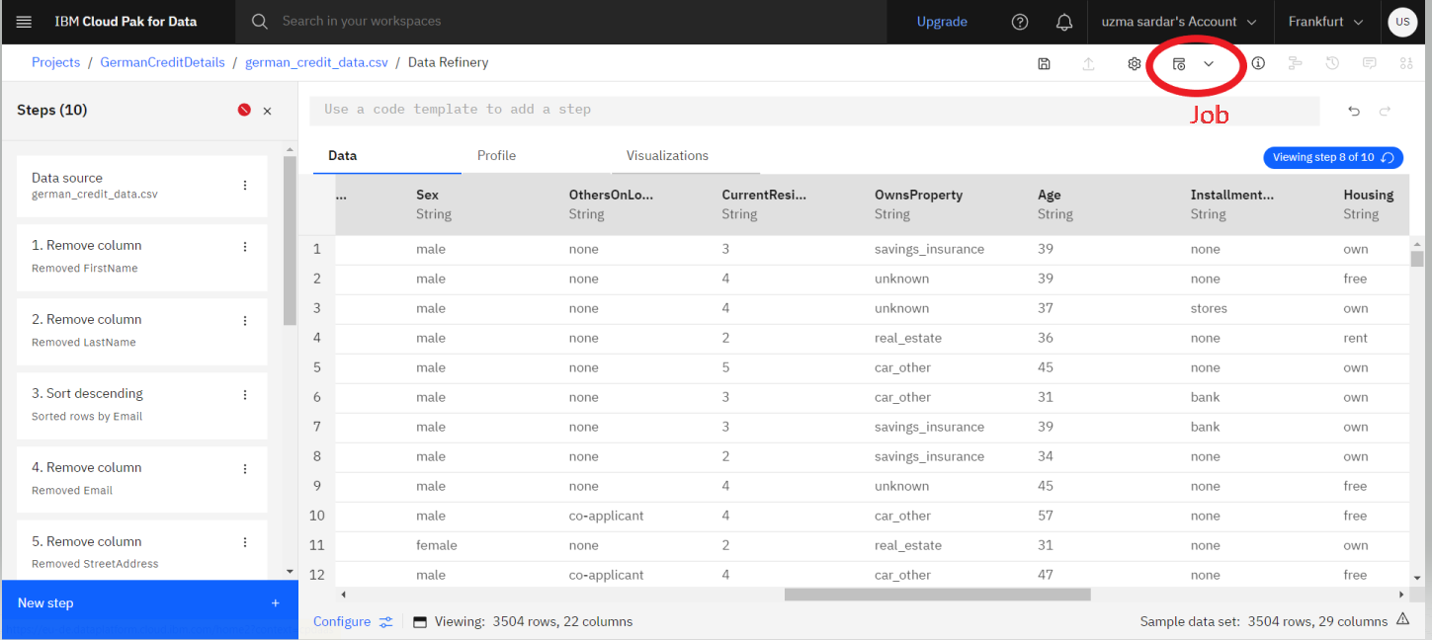

* Give the job a name and optional description, then click the *Next* button.

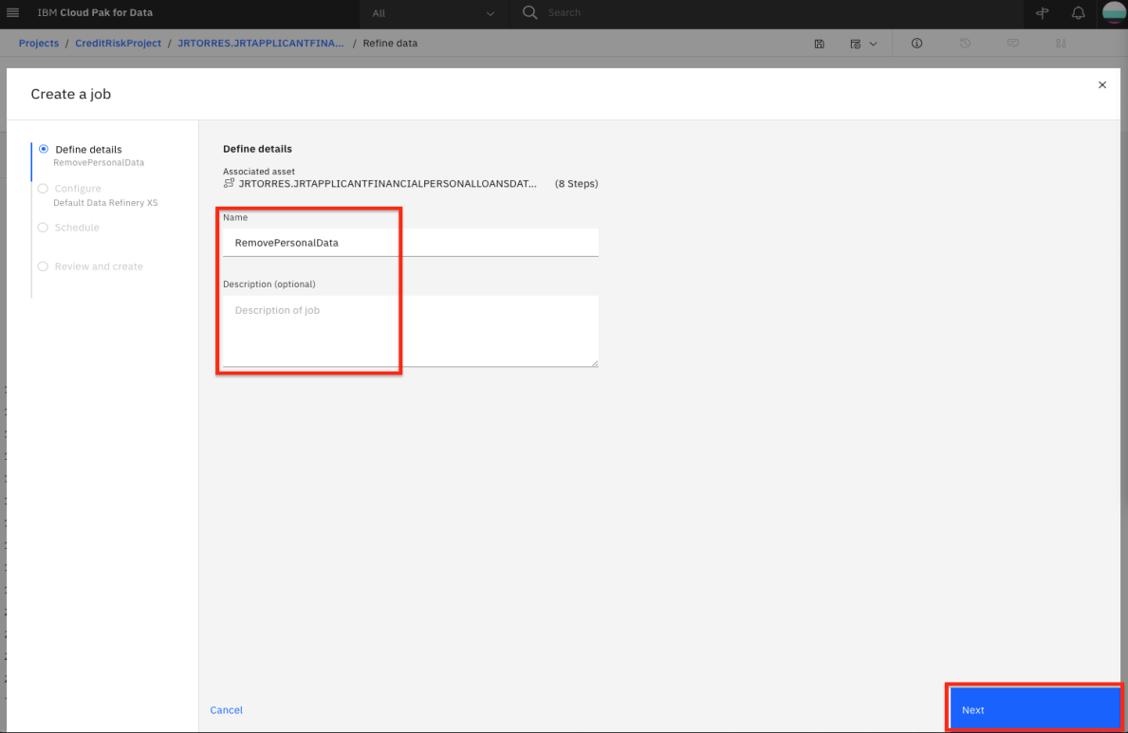

* The job will configure a default input and output data asset, as well as the runtime environment. Click the *Next* button.

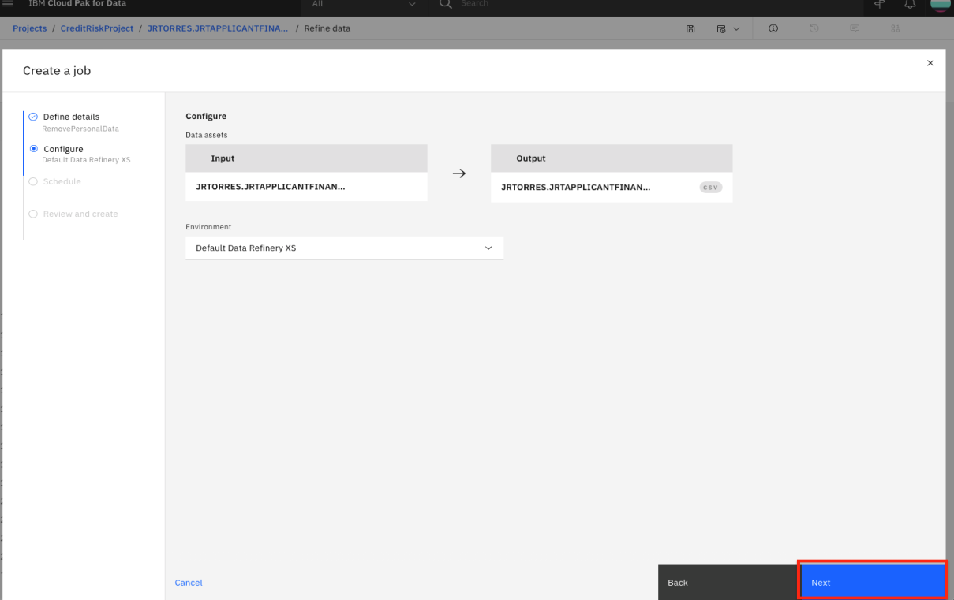

* We can set the job to run on a schedule. For now, leave the schedule off and click the *Next* button.

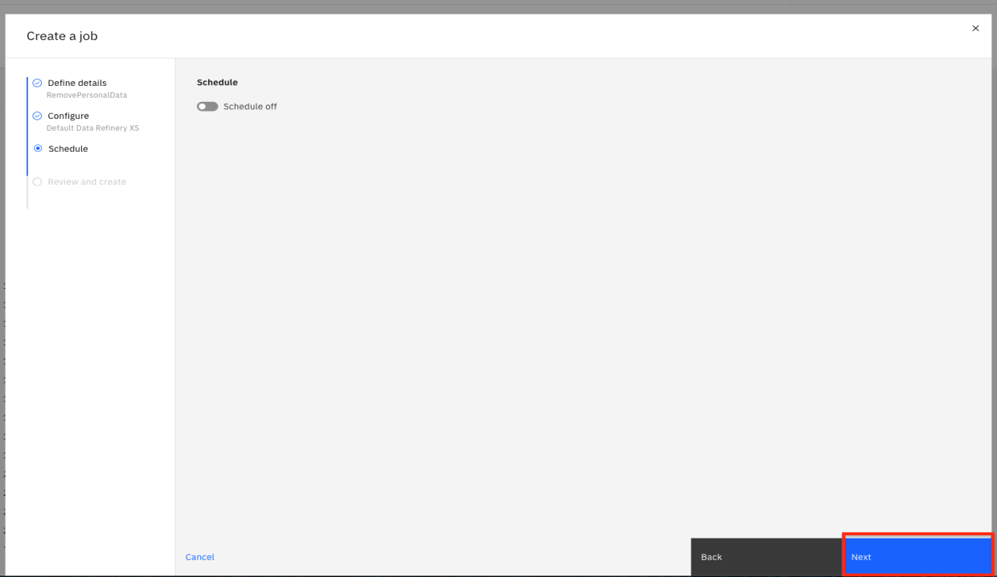

* Click the *Create and Run* button to save and run this job.

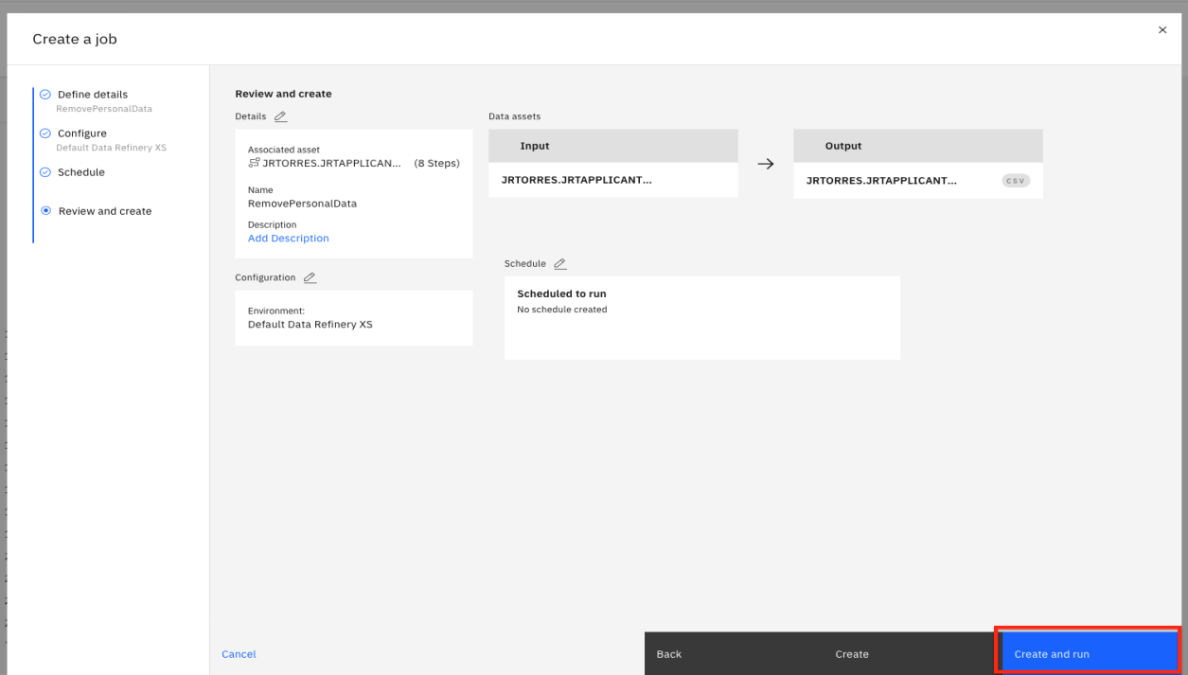

* This refinery flow will be saved to your project in the Data Refinery flows section of the project overview page. From that section you could revisit the flow to edit the steps or even see any execution jobs you have run. For now, we will move on to exploring our data.

## 3. Profile Data

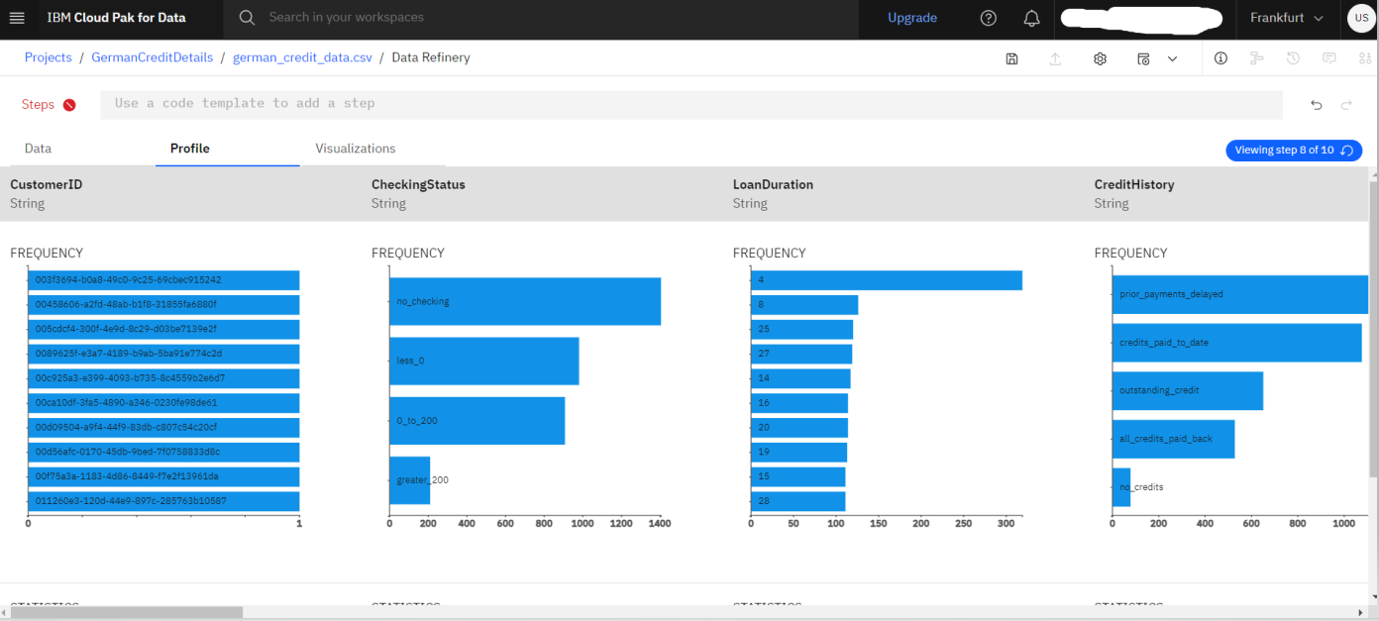

* Once the data profile loads, you can get insight into the data from the views and statistics:
* The median age of the applicants is 36, with the bulk under 49.
* About as many people had credits_paid_to_date as prior_payments_delayed. Few had no_credits.
* The median was 3 years for duration at current residence. Range was 1-6 years.

## 4. Visualize Data

Let's do some visual exploration of our data using charts and graphs. Note that this is an exploratory phase and we're looking for insights in out data. We can accomplish this in Data Refinery interactively without coding.

* Choose the Visualizations tab to bring up the page where you can select columns that you want to visualize. Select LoanAmount from the "Columns to visualize" drop down list as the first column and click Add another column to add another column. Next add LoanDuration and click the *Visualize data* button. The system will pick a suggested plot for you based on your data and show more suggested plot types at the top.

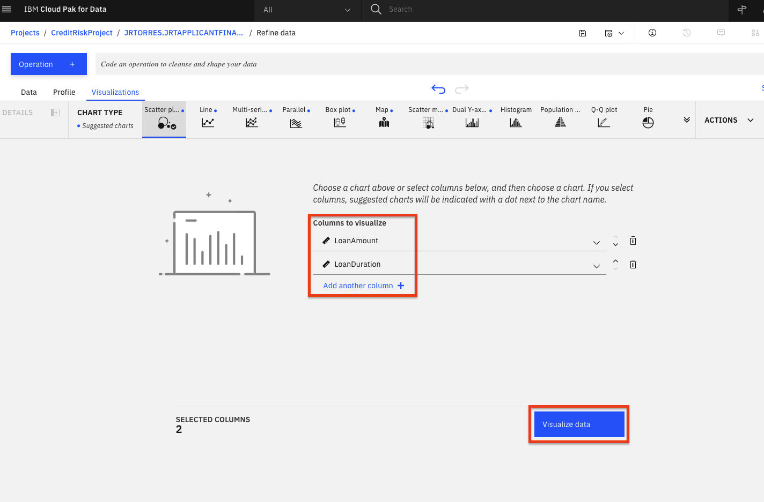

* Remember that we are most interested in knowing how these features impact a loan being at the risk. So, let's add the Risk as a color on top of our current scatter plot. That should help us visually see if there's something of interest here. From the left panel, click the Color Map drop down and select Risk. Also, to see the full data, drag the right side of the data selector at the bottom all the way to the right, in order to show all the data inside your plot.

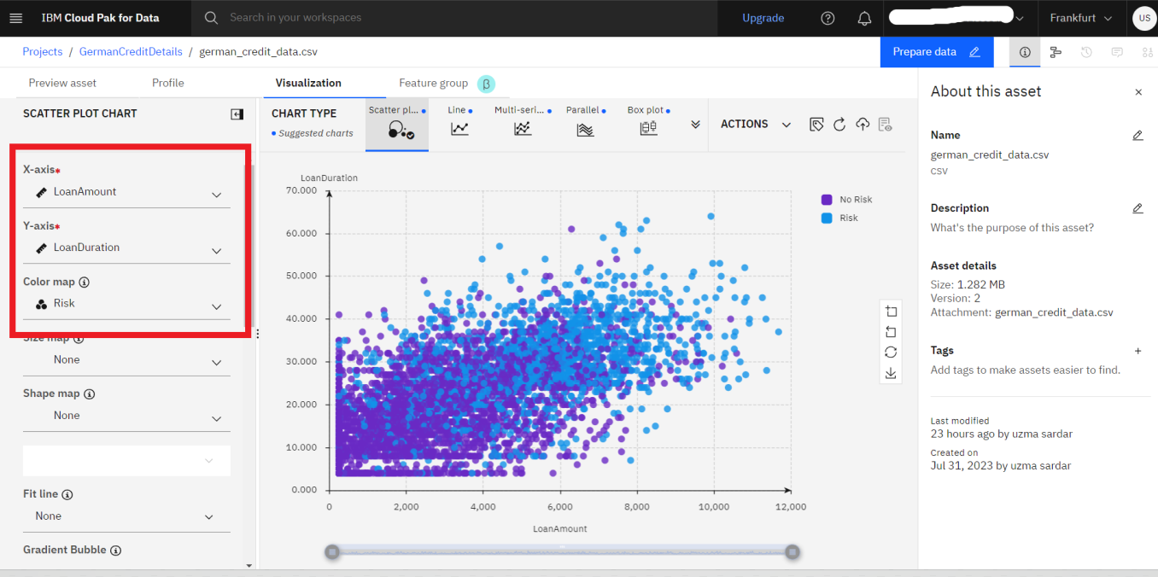

* We notice that there are more blue (risk) on this plot towards the top right, than there is on the bottom left. This is a good start as it shows that there is probably a relationship between the riskiness of a loan and its duration and amount. It appears that the higher the amount and duration, the riskier the loan. Interesting, let's dig in further in how the loan duration could play into the riskiness of a loan.

*Note: The colors used in your visualization may be different. Be sure to look at chart legend for clarification*

* Let's plot a histogram of the LoanDuration to see if we can notice anything. First, select Histogram from the Chart Type.
* On the left, select LoanDuration for the 'X-axis', select Risk in the 'Split By' section, check the Stacked option, uncheck the Show kde curve toggle, uncheck the Show distribution curve toggle. You should see a chart that looks like the following image.

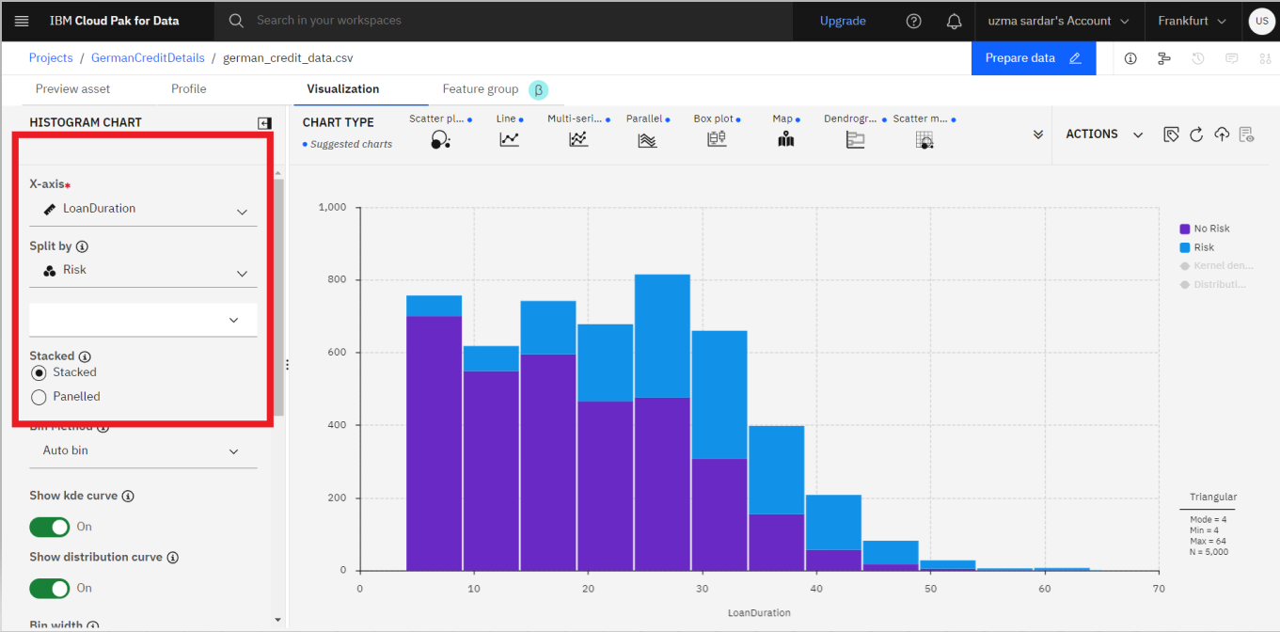

* It looks like the longer the duration the larger the blue bar (risky loan count) become and the smaller the dark blue bars (non risky loan count) become. That indicate loans with longer duration are in general more likely to be risky. However, we need more information.
* We next explore if there is some insight in terms of the riskiness of a loan based on its duration when broken down by the loan purpose. To do so, let's create a Heat Map plot.
* At the top of the page, in the Chart Type section, open the arrows on the right, select Heat Map.

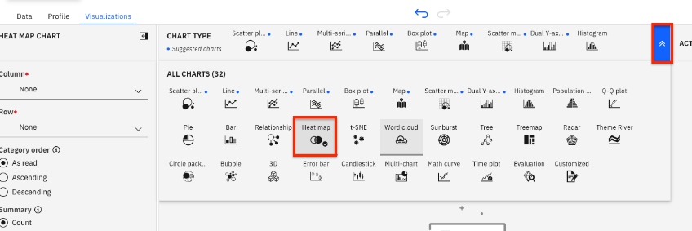

Next, select Risk in the column section and LoanPurpose for the Row section. Additionally, to see the effects of the loan duration, select Mean in the summary section, and select LoanDuration in the Value section.

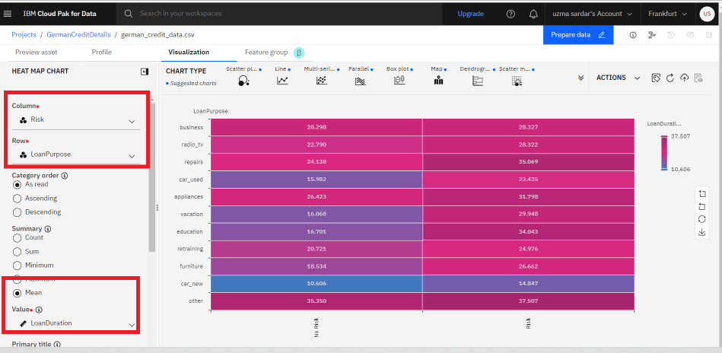

* You can now see that the least risky loans are those taken out for purchasing a new car and they are on average 10 years long. To the left of that cell we see that loans taken out for the same purpose that average around 15 years for term length seem to be more risky. So one could conclude the longer the loan term is, the more likely it will be risky. In contrast, we can see that both risky and non-risky loans for the other category seem to have the same average term length, so one could conclude that there's little, if any, relationship between loan length and its riskiness for the loans of type other.
* In general, for each row, the bigger the color difference between the right and left column, the more likely that loan duration plays a role for the riskiness of the loan category.

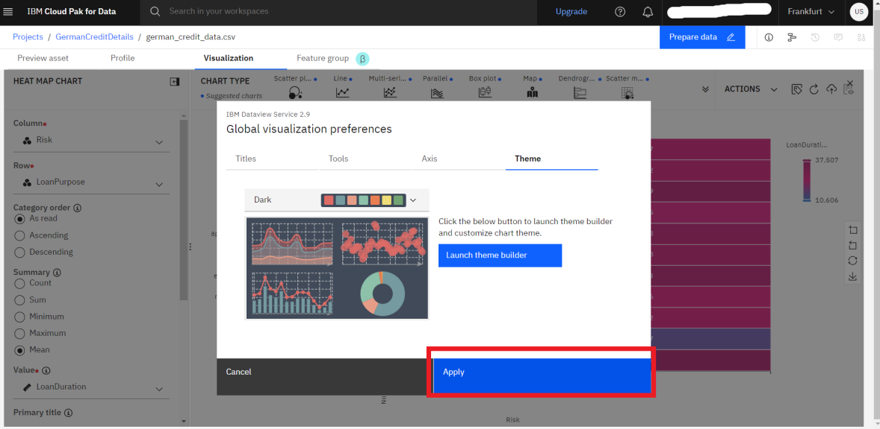

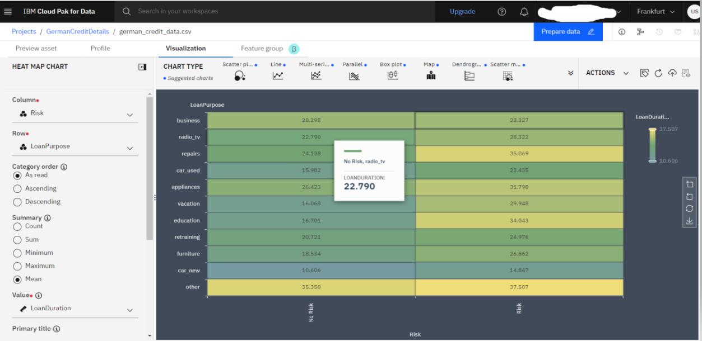

## Conclusion

We've seen some of the capabilities of the Data Refinery. We saw how we can transform data using R code, as well as using various operations on the columns such as changing the data type, removing empty rows, or deleting the column altogether. We next saw that all the steps in our Data Flow are recorded, so we can remove steps, repeat them, or edit an individual step. We were able to quickly profile the data, to see histograms and statistics for each column. And finally, we created more in-depth Visualizations, creating a scatter plot, histogram, and heatmap to explore the relationship between the riskiness of a loan and its duration, and purpose.

How to Kaggle a data for Practice

**Creating a Kaggle Account**:

* Go to the Kaggle website (<https://www.kaggle.com/>) and click on the "" button at the top right corner of the page.

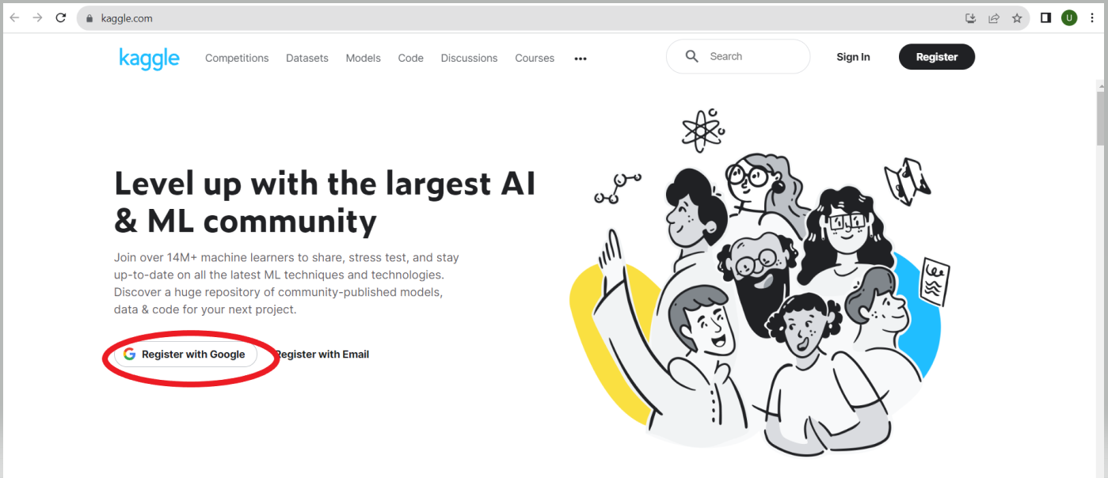

* Fill in the required details (name, email, password) and agree to the terms and conditions to create your account.

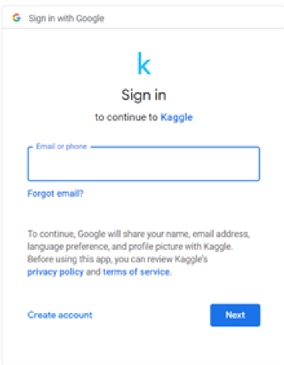

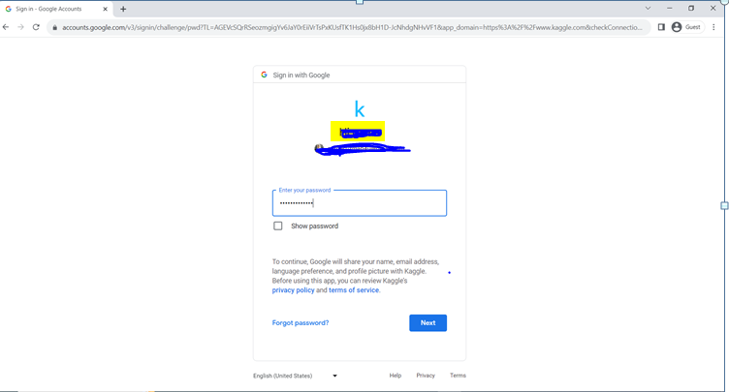

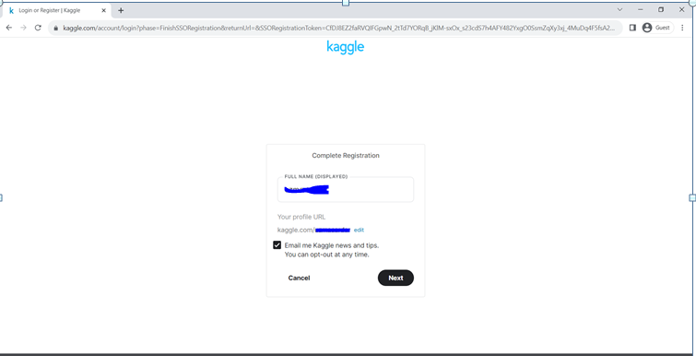

**Navigating Kaggle Datasets**:

* Once you have signed in to your Kaggle account, you will land on the Kaggle homepage.
* Click on the "Datasets" tab in the left menu to access the datasets section.

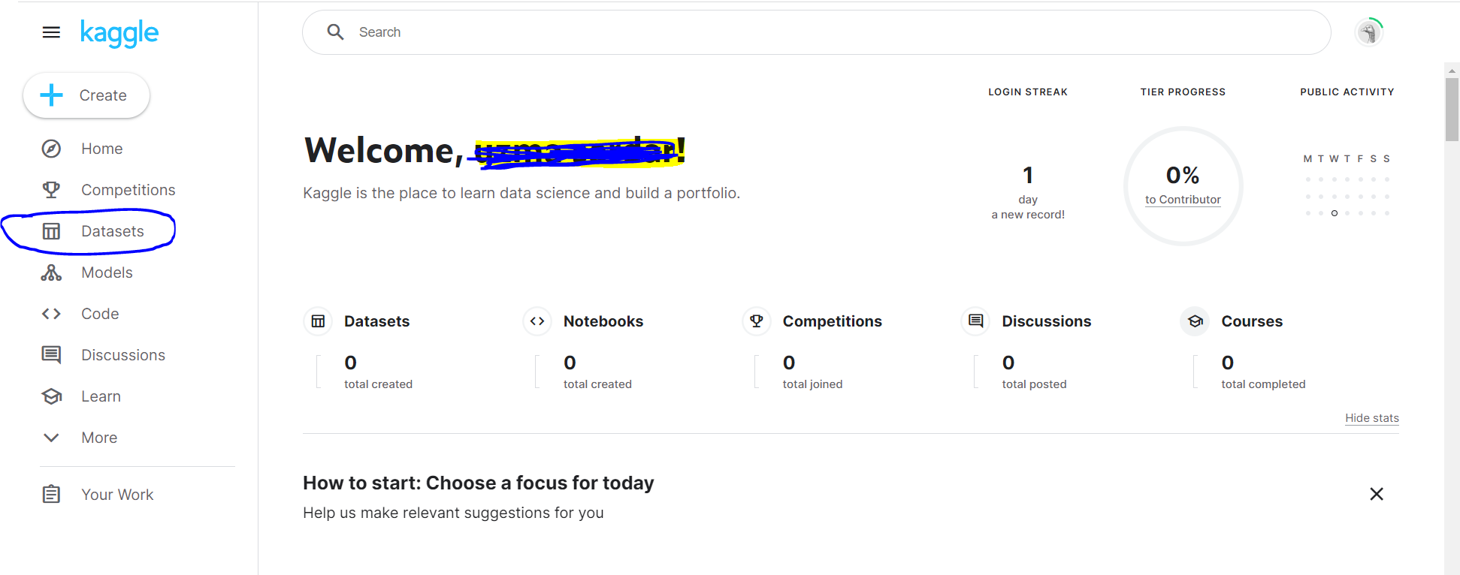

**Searching for Datasets**:

* Use the search bar to enter relevant keywords related to the engineering field or topic you are interested in.

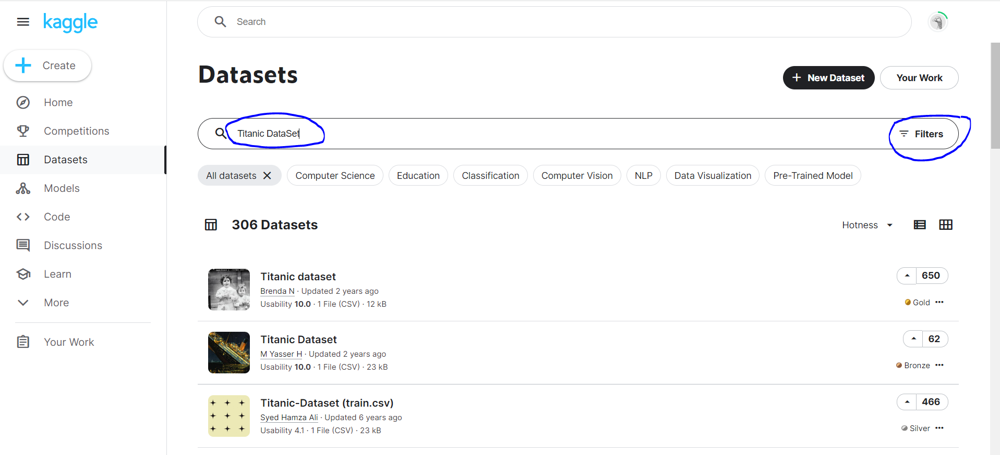

* You can apply filters on the left-hand side, such as "File types," "Tags," or "Licenses" to refine your search results.

**Dataset Details**:

* Click on a dataset of your choice to view its details, including description, size, number of downloads, and license information.
* Make sure to read the dataset's description and license to ensure it suits your needs.

**Downloading a Dataset**:

* If you find a suitable dataset, click on the "Download" button to download it to your local machine.

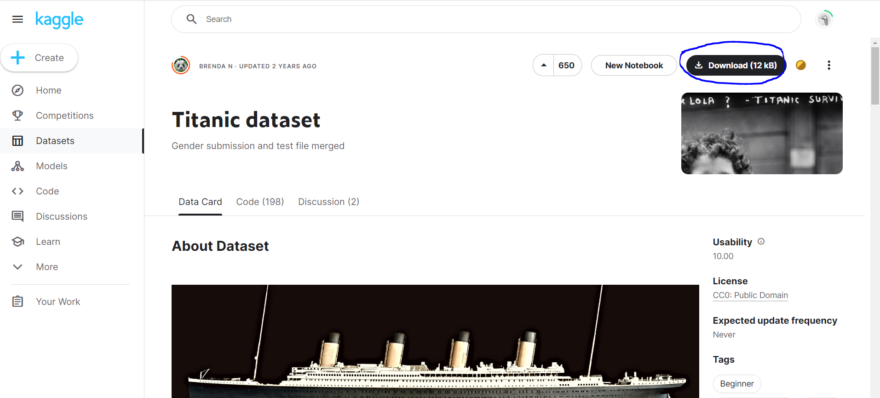

* The dataset may be available in various formats like CSV, JSON, or SQL, depending on the dataset provider's choice.